KUMARAGURU COLLEGE OF TECHNOLOGY

24ADT015-FINANCE, ECONOMICS AND MARKETING

NAME : Nishanth P
ROLL NO : 24BAD405

Economic Value Added (EVA): A Comprehensive Analysis of True Economic Profit

Introduction to Value-Based Management
Economic Value Added (EVA) is a registered trademark of Stern Stewart & Co., representing a powerful and increasingly adopted financial metric that aims to measure a company's true economic profit. Unlike traditional accounting measures like Net Income or Earnings Per Share (EPS), EVA explicitly incorporates the cost of capital—both debt and equity—required to generate those earnings. In essence, EVA answers the critical question: is the business generating a return that exceeds the cost of all the capital invested in it?
If a company's EVA is positive, it is creating shareholder wealth; if it is negative, it is destroying wealth. This focus on capital costs makes EVA a crucial component of Value-Based Management (VBM) systems, aligning managerial decisions with the goal of maximizing shareholder returns. The metric serves not only as a performance measure but also as a basis for executive compensation, motivating managers to maximize returns and efficiently manage the asset base.

Section 1: The Core Concept and Formula
EVA is fundamentally a measure of the residual wealth created by a firm after deducting its cost of capital from its operating profit. It provides a clearer picture of economic reality than figures derived solely from generally accepted accounting principles (GAAP), which often treat equity capital as "free" (i.e., they do not explicitly account for the opportunity cost borne by shareholders).
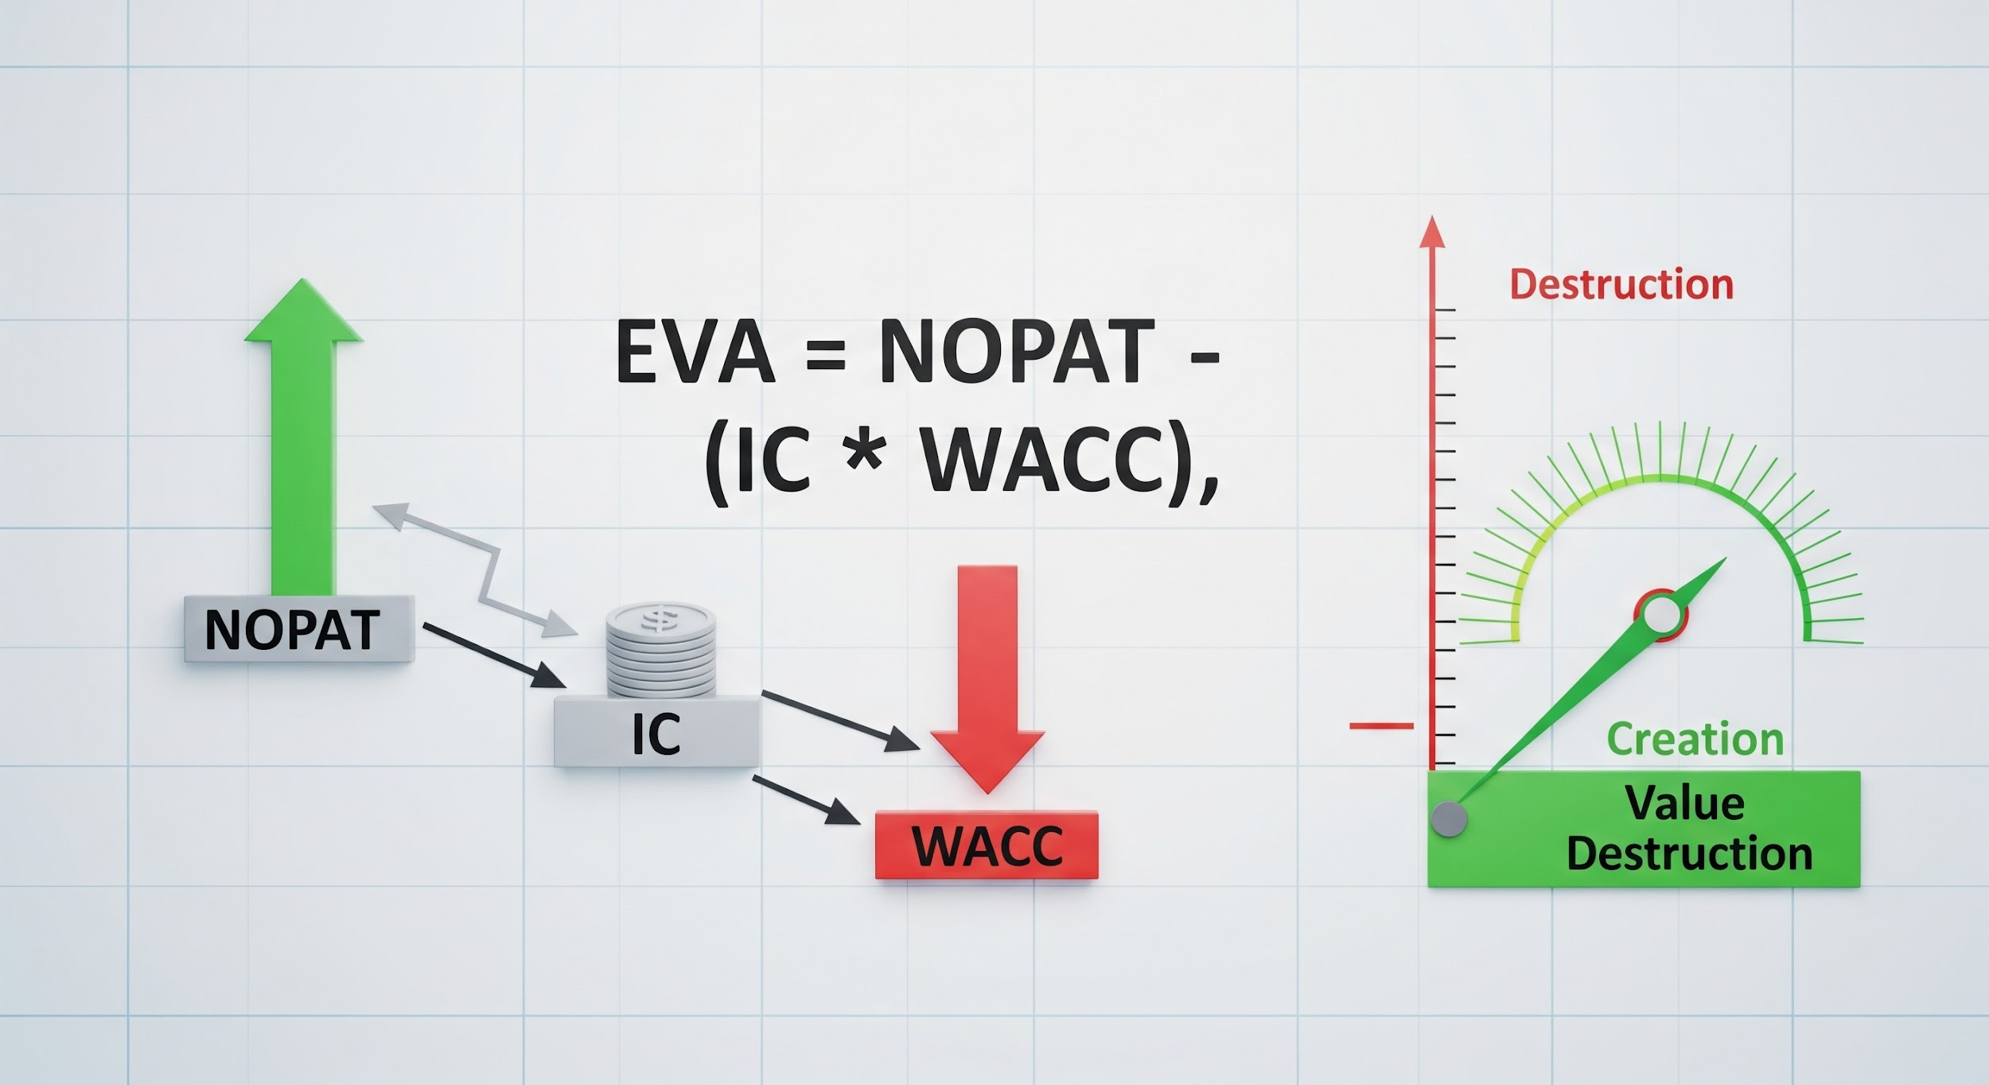

1.1 The Mathematical Definition (Formula and Components)
The calculation of Economic Value Added can be summarized using the following core formula, which ensures all capital costs are explicitly accounted for:
EVA = NOPAT - (IC * WACC)
Alternatively, it can be expressed in terms of the return on investment:
EVA = (ROIC - WACC) * IC
Where the components are defined as follows:
- NOPAT (Net Operating Profit After Taxes): This represents the company’s theoretical cash earnings if it were an all-equity firm. It is calculated as Operating Income (EBIT) multiplied by
$$(1 - \text{Tax Rate})$$
. This metric is crucial as it focuses purely on the operational efficiency, independent of financing decisions.
- IC (Invested Capital or Capital Employed): This is the total capital used by the business, including debt and equity, adjusted for certain off-balance-sheet items. It represents the total amount of money tied up in the business's operations.
- WACC (Weighted Average Cost of Capital): This is the weighted average rate that a company expects to pay to finance its assets. It represents the opportunity cost of capital—the minimum rate of return a company must earn on its existing asset base to satisfy its creditors and shareholders.

Section 2: Detailed Steps for EVA Calculation
The calculation of EVA is often more involved than standard metrics due to the necessary accounting adjustments required to convert GAAP figures into "economic" figures. Stern Stewart & Co. suggests making up to 164 potential adjustments, though most companies focus on a few key ones.

2.1 Key Calculation Steps (Facts and Process)
The calculation process moves from publicly reported financial statements toward an economically accurate view of the business:
- Calculate NOPAT:
  - Start with operating profit (EBIT).
  - Adjust EBIT for any items considered non-operating (e.g., one-time charges, goodwill amortization, R&D expenses that should be capitalized).
  - Apply the actual cash tax rate to arrive at NOPAT.
  - Fact: A key adjustment is capitalizing research and development (R&D) expenses and treating them as an asset, which better reflects their long-term value creation potential rather than immediate expensing.
- Calculate Invested Capital (IC):
  - Sum up all sources of capital: long-term debt, preferred equity, and common equity.
  - Alternatively, sum up operating assets (net working capital + fixed assets).
  - Crucially, apply the same accounting adjustments made to NOPAT (e.g., adding back the capitalized R&D to the asset base).
- Determine the WACC:
  - Calculate the cost of debt (post-tax) and the cost of equity (using models like the Capital Asset Pricing Model or CAPM).
  - Weight these costs by the proportion of debt and equity in the firm's capital structure.
  - Fact: WACC is the hurdle rate. If the return generated by the investment is less than WACC, the investment is uneconomic, even if it reports positive Net Income.
- Calculate the Capital Charge:
  - Multiply the Invested Capital (IC) by the Weighted Average Cost of Capital (WACC). This figure represents the dollar cost of financing all the capital used by the business.
  - Formula:
$$\text{Capital Charge} = \text{IC} \times \text{WACC}$$
- Determine EVA:
  - Subtract the Capital Charge from NOPAT to derive the final EVA figure.
  - If EVA > 0, the firm is creating value above the required return.
  - If EVA < 0, the firm is destroying value.
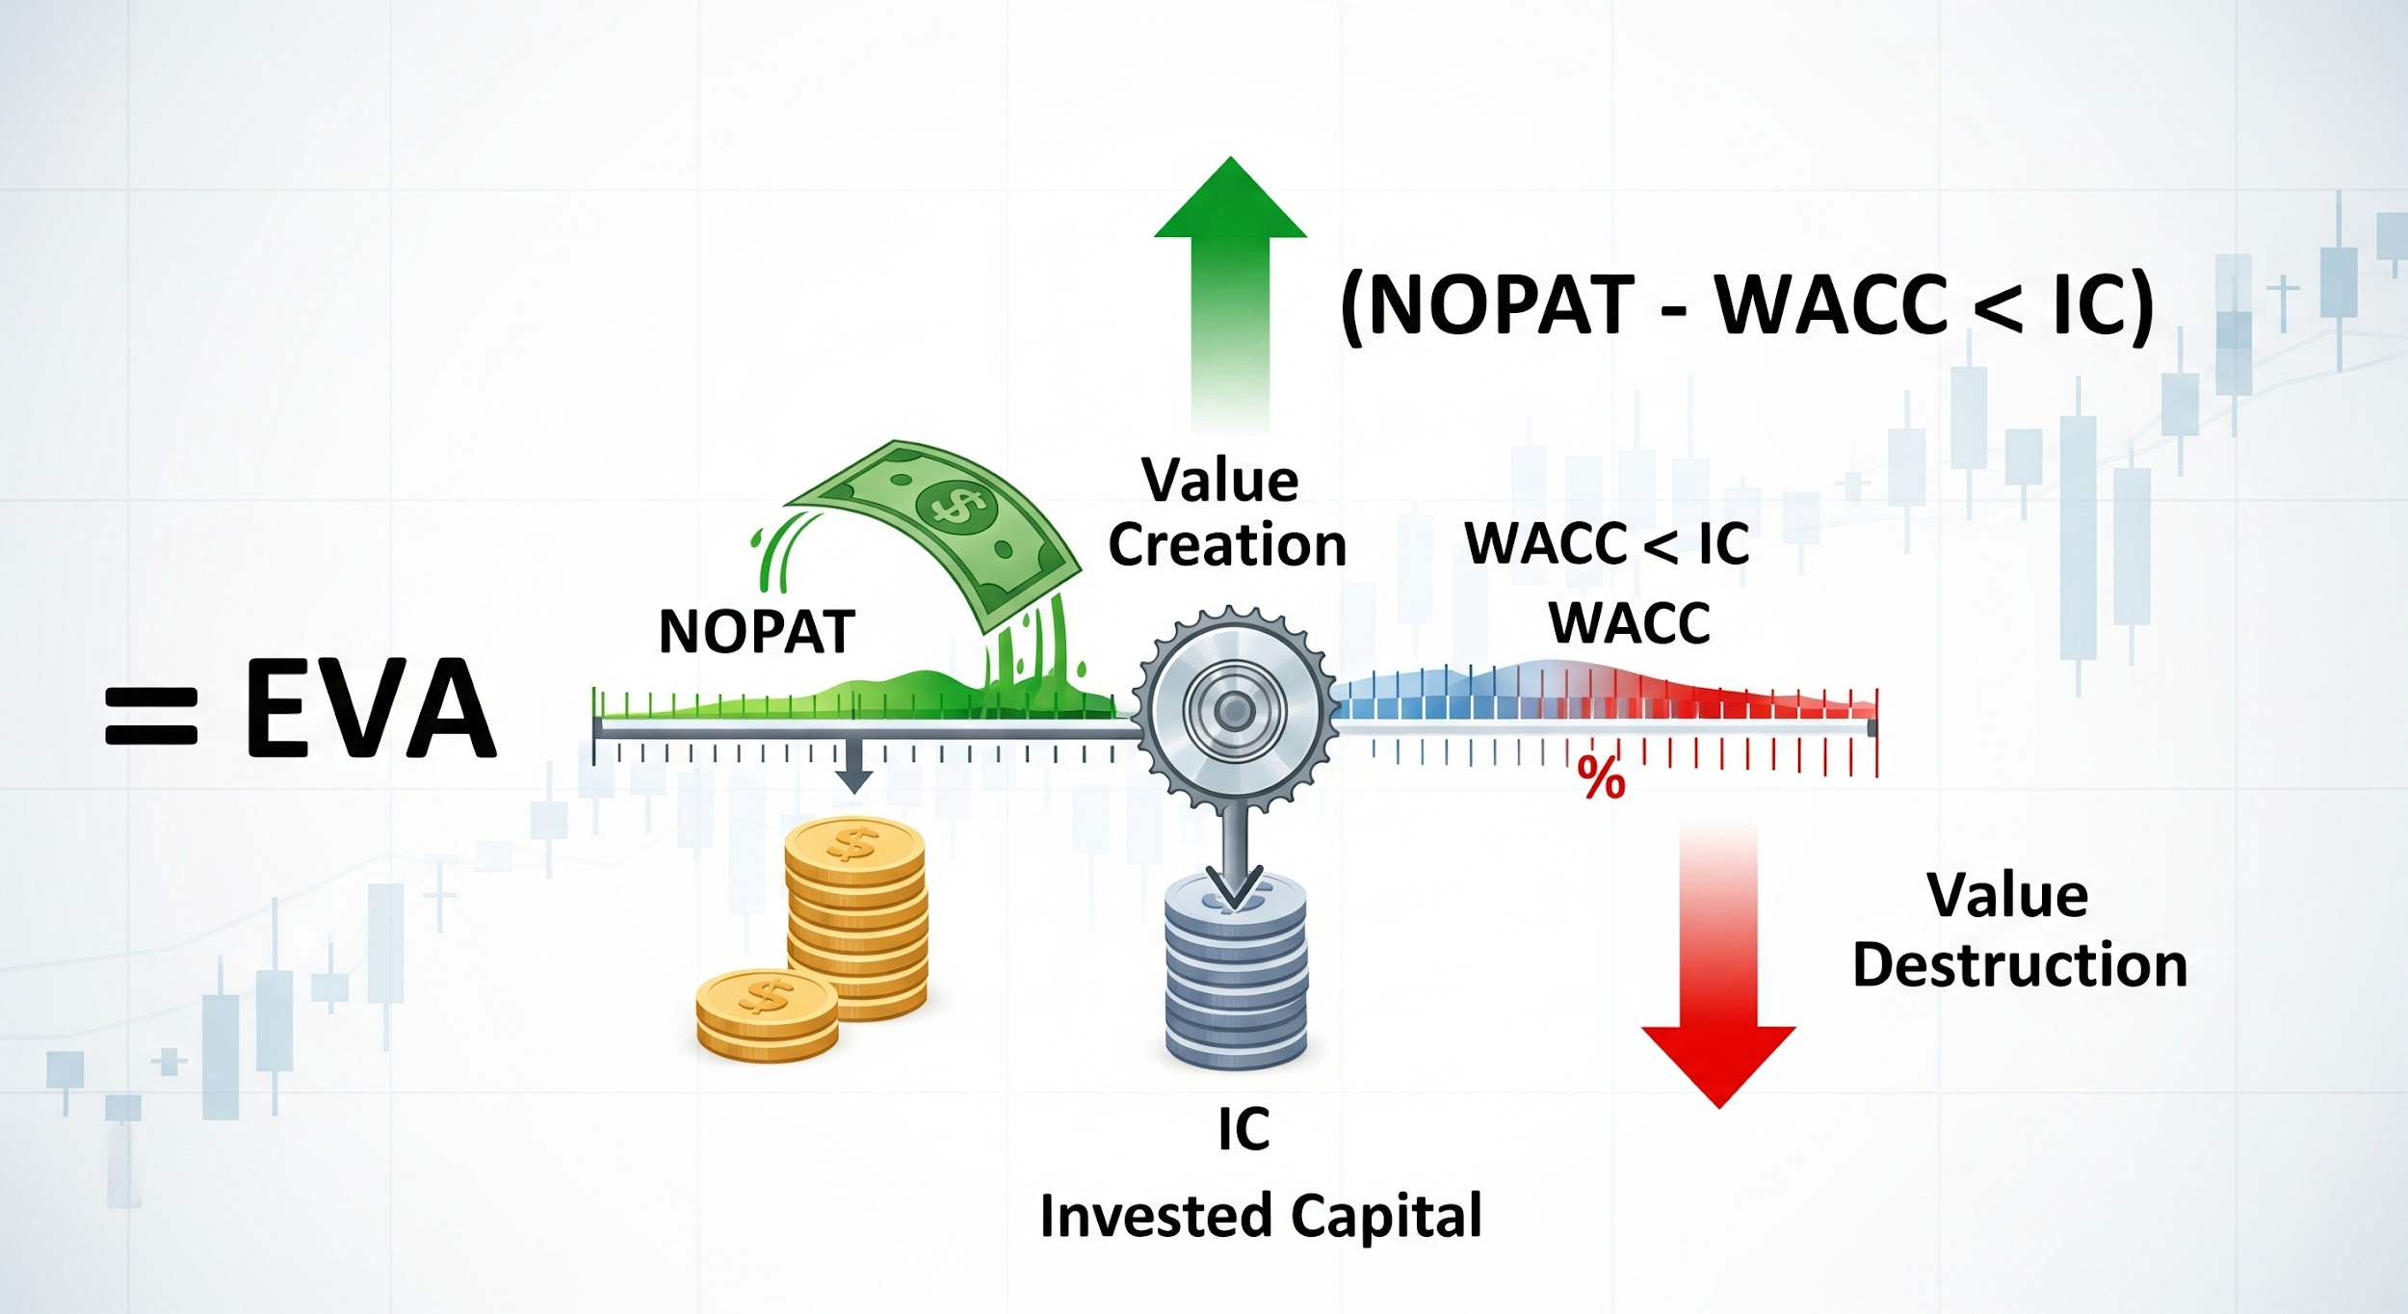

Section 3: EVA’s Superiority and Limitations

3.1 Advantages of Using EVA
EVA addresses several inherent flaws in traditional accounting measures, making it a powerful internal and external financial tool. Its primary benefits stem from its ability to align all corporate activities with value creation.
- Addresses the Cost of Equity: Traditional net income calculations only deduct the interest cost of debt. EVA is the only residual income measure that explicitly deducts the dollar cost of both debt and equity capital, providing a true measure of economic profit.
- Aligns Management Incentives: When EVA is linked to management compensation (e.g., bonuses based on EVA improvement), managers are motivated to make decisions that truly benefit shareholders. This often leads to the divestiture of underperforming assets (which destroy EVA) and the pursuit of high-return projects (which create EVA).
- Improves Capital Allocation: Because EVA penalizes the excessive use of capital, it encourages managers to minimize the asset base required for any given level of profit. This leads to better capital expenditure decisions and working capital management.
- Fact: Studies have shown that EVA can correlate more closely with changes in a company's market value (stock price) over the long term than traditional earnings metrics, confirming its relevance to investor wealth.

3.2 Disadvantages and Practical Limitations
Despite its theoretical superiority, EVA is not without its practical challenges, particularly in complex or heavily regulated industries.
- Complexity and Subjectivity: The requirement for extensive accounting adjustments (e.g., capitalizing R&D, adjusting for goodwill) introduces complexity and subjectivity. Different companies might use different adjustments, making cross-firm comparisons difficult.
- Reliance on WACC Estimation: The WACC calculation itself relies on several estimates, notably the cost of equity, which uses estimates like the market risk premium and beta. Small errors in the WACC can significantly alter the EVA figure, leading to potential misjudgments.
- Short-Term Focus Risk: While intended to be long-term, an over-reliance on the annual EVA figure can still tempt managers to cut necessary long-term investments (like R&D or marketing) to boost short-term NOPAT, thus temporarily improving EVA but ultimately damaging future value.
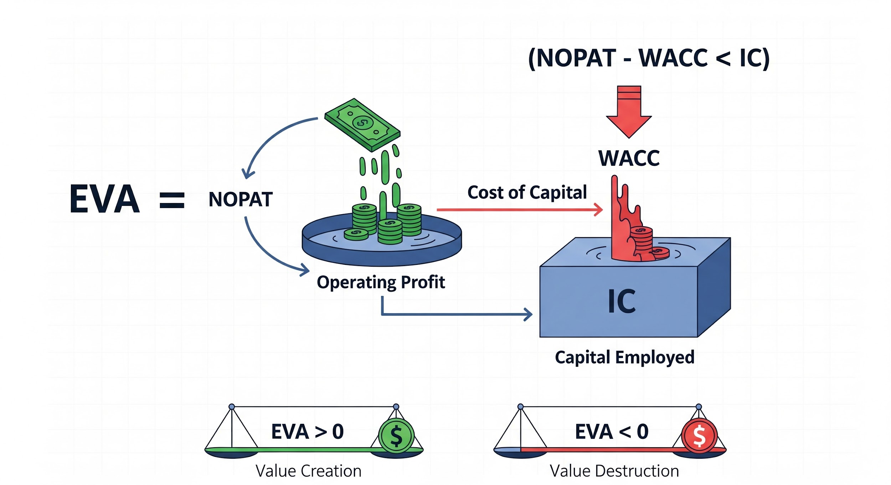

Section 4: EVA vs. Traditional Performance Metrics
The fundamental difference between EVA and traditional metrics like Net Income or Return on Investment (ROI) is the explicit deduction of the capital charge.
Metric | Calculation Basis | Focus of Management | Value Measure
Net Income | Revenues - Expenses (including interest) | Revenue maximization | Accounting Profit
ROI | Net Income / Invested Capital | Percentage Return on Assets | Efficiency Ratio
EVA | NOPAT - Capital Charge | Value Creation in Absolute Dollars | Economic Profit
- Why EVA is Superior: A project may have a positive Net Income, meaning it made an accounting profit. However, if the ROI on that project is 8%, and the WACC is 10%, the project is destroying value. It is not generating enough return to cover the opportunity cost of the capital used. In this case, Net Income is positive, but EVA is negative. EVA correctly identifies this project as a wealth-destroyer, forcing managers to seek projects where the return exceeds the cost of financing.

Conclusion
Economic Value Added is more than just a financial formula; it is a philosophy of financial management. By penalizing capital consumption, it fundamentally changes how managers view assets and investments, driving a focus on generating returns above the shareholder's required rate of return. While the calculation requires diligence due to necessary accounting adjustments and accurate WACC estimation, its benefit lies in its singular, clear objective: the maximization of shareholder value in absolute dollar terms. EVA thus stands as a sophisticated, necessary evolution in corporate performance measurement, ensuring that profits are not merely accounting artifacts but genuine indicators of economic wealth creation.

